NAME: | PARVENDHAN C
ROLL NO: | 241801197
DEPT: | AI&DS

- Create the animals table. Write the syntax you will use to create the table.
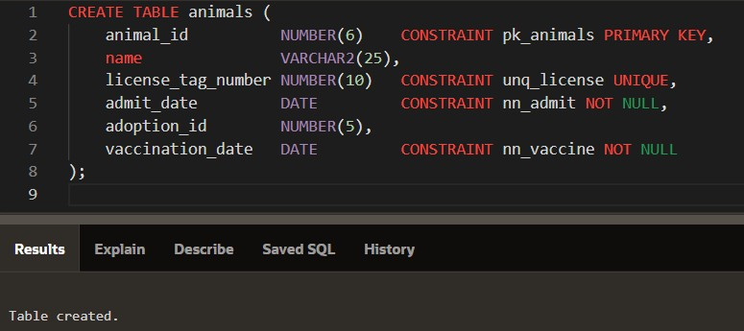

- Enter one row into the table. Execute a SELECT * statement to verify your input. Refer to the graphic below for input.
ANIMAL_I D NAM E LICENSE_TAG_NUMBE R ADMIT_DAT E ADOPTION_I D
VACCINATION_DAT E
101 Spot 35540 10-Oct-2004 205 12-Oct-2004

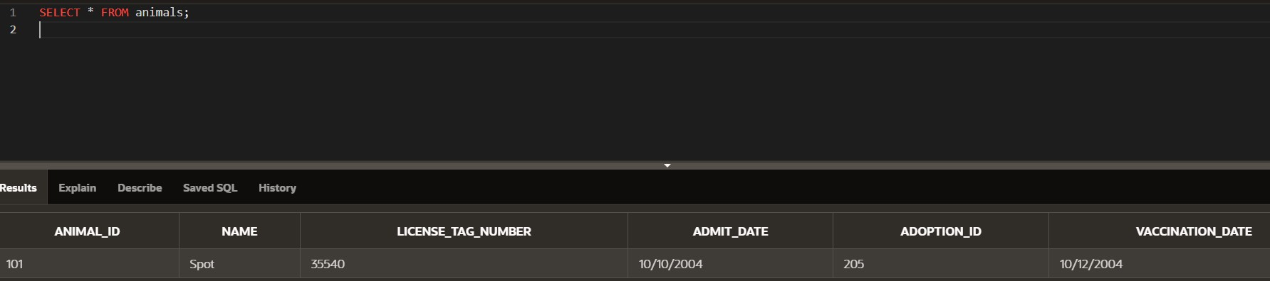

5. Write the syntax to create a foreign key (adoption_id) in the animals table that has a corresponding primary-key reference in the adoptions table. Show both the column-level and table-level syntax. Note that because you have not actually created an adoptions table, no adoption_id primary key exists, so the foreign key cannot be added to the animals table.
